**PRACTICAL – 5**

**Aim:** To view records in the table “Student”.

Code:

Output (Python):

Output (MySQL):

**PRACTICAL – 6**

**Aim: To insert a record in the table “Student”.**

**Code:**

Output:

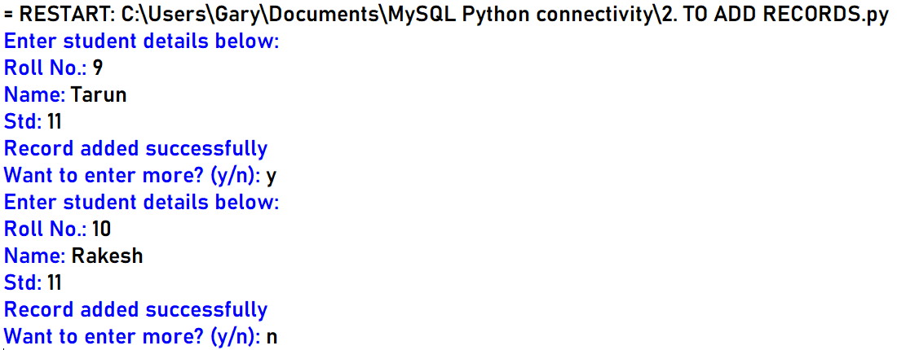

Result:

**PRACTICAL – 7**

Aim: To update a record in the table “Student”.

Code:

Output:

Result:

**PRACTICAL – 8**

Aim: To delete a record from the table “Student”.

Code:

Output:

Result:

**PRACTICAL – 9**

Aim: Make a script to operate on the table “Student” using a CUI menu.

Code:

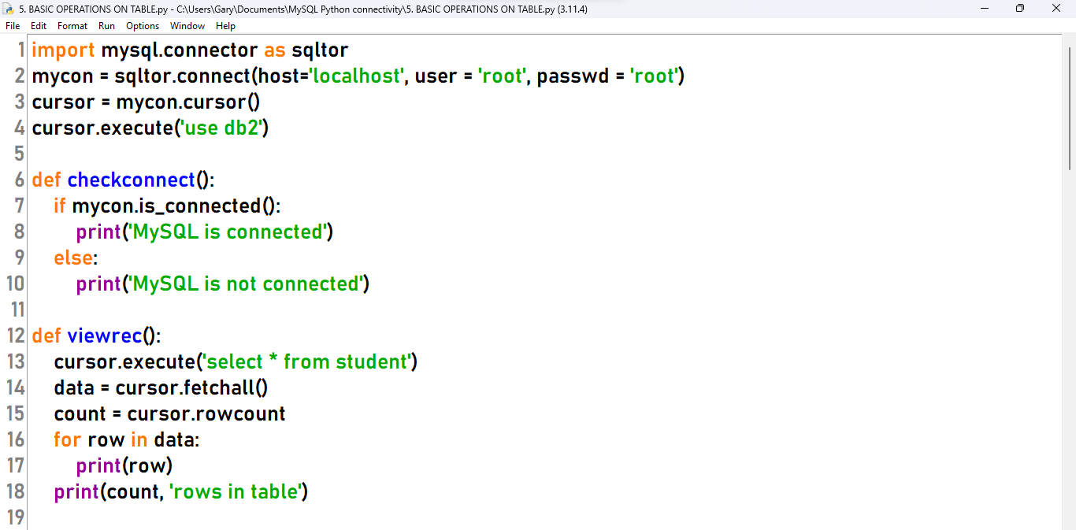

Output:

